**ITS290F Human Computer Interaction & User Experience Design**

**Lab 2. HTML DOM**

What you’ll learn in this lab:

* HTML DOM (Document Object Model)
* Coding with CodePen

**1. What is the HTML DOM?**

The HTML DOM is an Object Model for HTML. It defines:

* HTML elements as objects
* Properties for all HTML elements
* Methods for all HTML elements
* Events for all HTML elements

The HTML DOM is an API (Programming Interface) for JavaScript:

* JavaScript can add/change/remove HTML elements
* JavaScript can add/change/remove HTML attributes
* JavaScript can add/change/remove CSS styles
* JavaScript can react to HTML events
* JavaScript can add/change/remove HTML events

When a web page is loaded, the browser creates a **D**ocument **O**bject **M**odel of the page.

The **HTML DOM** model is constructed as a tree of **Objects**:

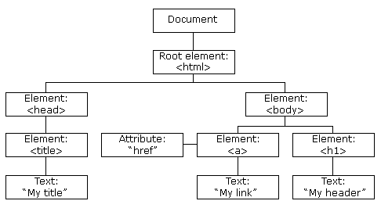

**2. Finding HTML Elements**

When you want to access HTML elements with JavaScript, you have to find the elements first.

There are a couple of ways to do this:

* Finding HTML elements by id
* Finding HTML elements by tag name
* Finding HTML elements by class name
* Finding HTML elements by CSS selectors
* Finding HTML elements by HTML object collections

The easiest way to find an HTML element in the DOM, is by using the element id.

This example finds the element with id="intro":

var myElement = document.getElementById("intro");

If the element is found, the method will return the element as an object (in myElement).

If the element is not found, myElement will contain null.

**3. Readings**

Two suggested readings from w3schools

1. JavaScript HTML DOM tutorial

<https://www.w3schools.com/js/js_htmldom.asp>)

1. JavaScript and HTML DOM reference

<https://www.w3schools.com/jsref/default.asp>

**4. Exercise**

On your own, spend time becoming familiar with the HTML DOM. For this part, practice manipulating HTML elements with different element lookup methods. Copy the given HTML template from the solution box of each exercise below and paste it to the HTML section of CodePen. Finish the code on CodePen and update the boxes with your solutions.

**For exercises 1–7, update only the code within the <script></script> section.**

You may refer to the online JavaScript HTML DOM tutorial from w3schools (<https://www.w3schools.com/js/js_htmldom.asp>) and the reference (<https://www.w3schools.com/jsref/default.asp>).

**Exercise 1**

Use the getElementById method to find the <p> element, and change its text to “Hello”.

|  |
| --- |
| **Your Solution** |
| <p id="p1">Paragraph 1</p>  <script>  Document.getElementById(“p1”).innerHTML = “Hello”  </script> |

**Exercise 2**

Use the getElementsByTagName method to find the first <p> element, and change its text to “Hello”, and then find the second <p> element, and change its text to “World”.

|  |
| --- |
| **Your Solution** |
| <p id="p1">Paragraph 1</p>  <p id="p2">Paragraph 2</p>  <script>  Document.getElementsByTagName(“p”).innerHTML = “World”  </script> |

**Exercise 3**

Use the getElementsByClassName method to read the elements with class name “para”. Update the text of the third “para” element with the concatenated text of the first and second elements, i.e. the third paragraph should display “Hello Hong Kong”.

|  |
| --- |
| **Your Solution** |
| <p class="para">Hello </p>  <p class="para">Hong Kong </p>  <p class="para"></p>  <script> var x = document.getElementsByClassName(“para”);  x[2].innerHTML = x[0].innerHTML + x[1].innerHTML;  </script> |

**Exercise 4**

Use the getElementById method to change the source of image to “http://www.ouhk.edu.hk/AAU/images/IOH.jpg”.

|  |
| --- |
| **Your Solution** |
| <p><img id="image" src="http://www.ouhk.edu.hk/AAU/images/JCC.jpg"></p>  <script>  document.getElementById(“image”).src = <http://www.ouhk.edu.hk//AAU/images/IOH.jpg>;    </script> |

**Exercise 5**

Use HTML DOM to change the value of the input field to “OUHK”.

|  |
| --- |
| **Your Solution** |
| <input type="text" id="inputText" value="Hello"><p>  <script>  Document.getElementById(“inputText”).value=”World”;  </script> |

**Exercise 6**

Use HTML DOM to change the font size of the <p> element to 40 pixels. **Hints**: Look for “fontSize” in DOM Style (<https://www.w3schools.com/jsref/dom_obj_style.asp>).

|  |
| --- |
| **Your Solution** |
| <p id="p1">A paragraph</p>  <script>  document.getElementById(“p1”).style.fontSize = “40px”;  </script> |

**Exercise 7**

Use HTML DOM to hide the <p> element. **Hints**: Look for “visibility” in DOM Style (<https://www.w3schools.com/jsref/dom_obj_style.asp>).

|  |
| --- |
| **Your Solution** |
| <p id="p1">A secret message</p>  <script>  document.getElementById(“p1”).style.visibility = “hidden”;    </script> |

**Exercise 8 (Mastery)**

Implement the changeColor() function in the JS part so that the user can change the color of the word “cow” with the given text color input, such as red, green, and yellow. See the example screens below.

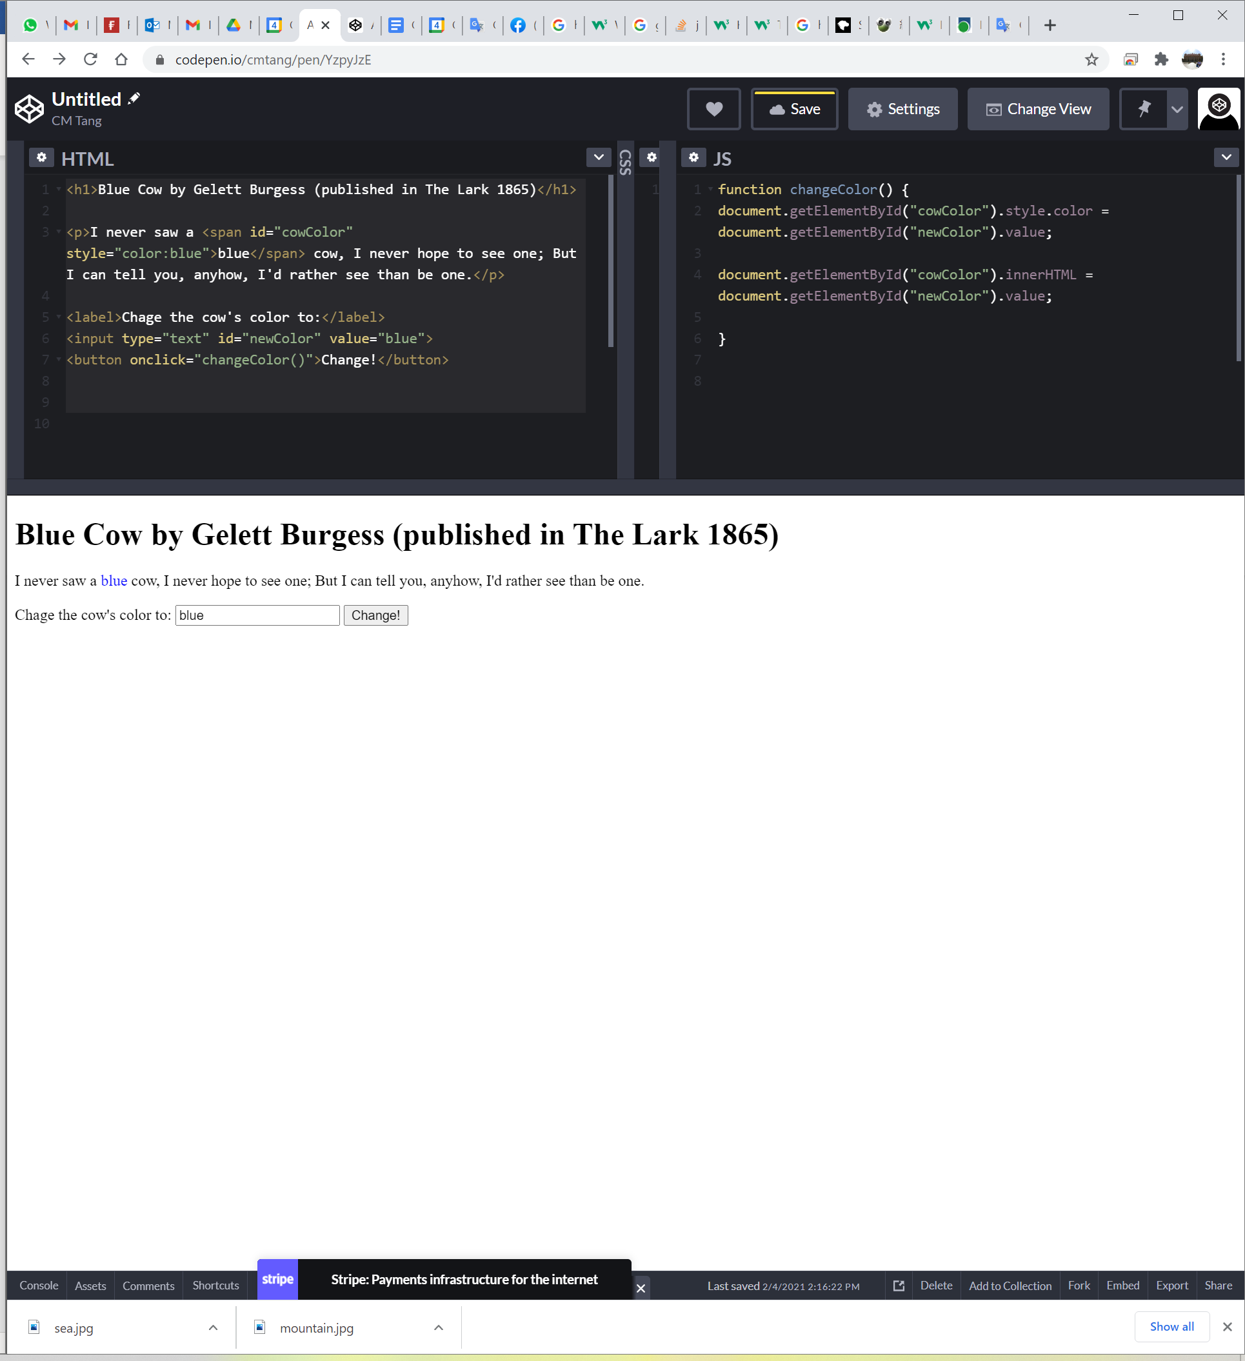

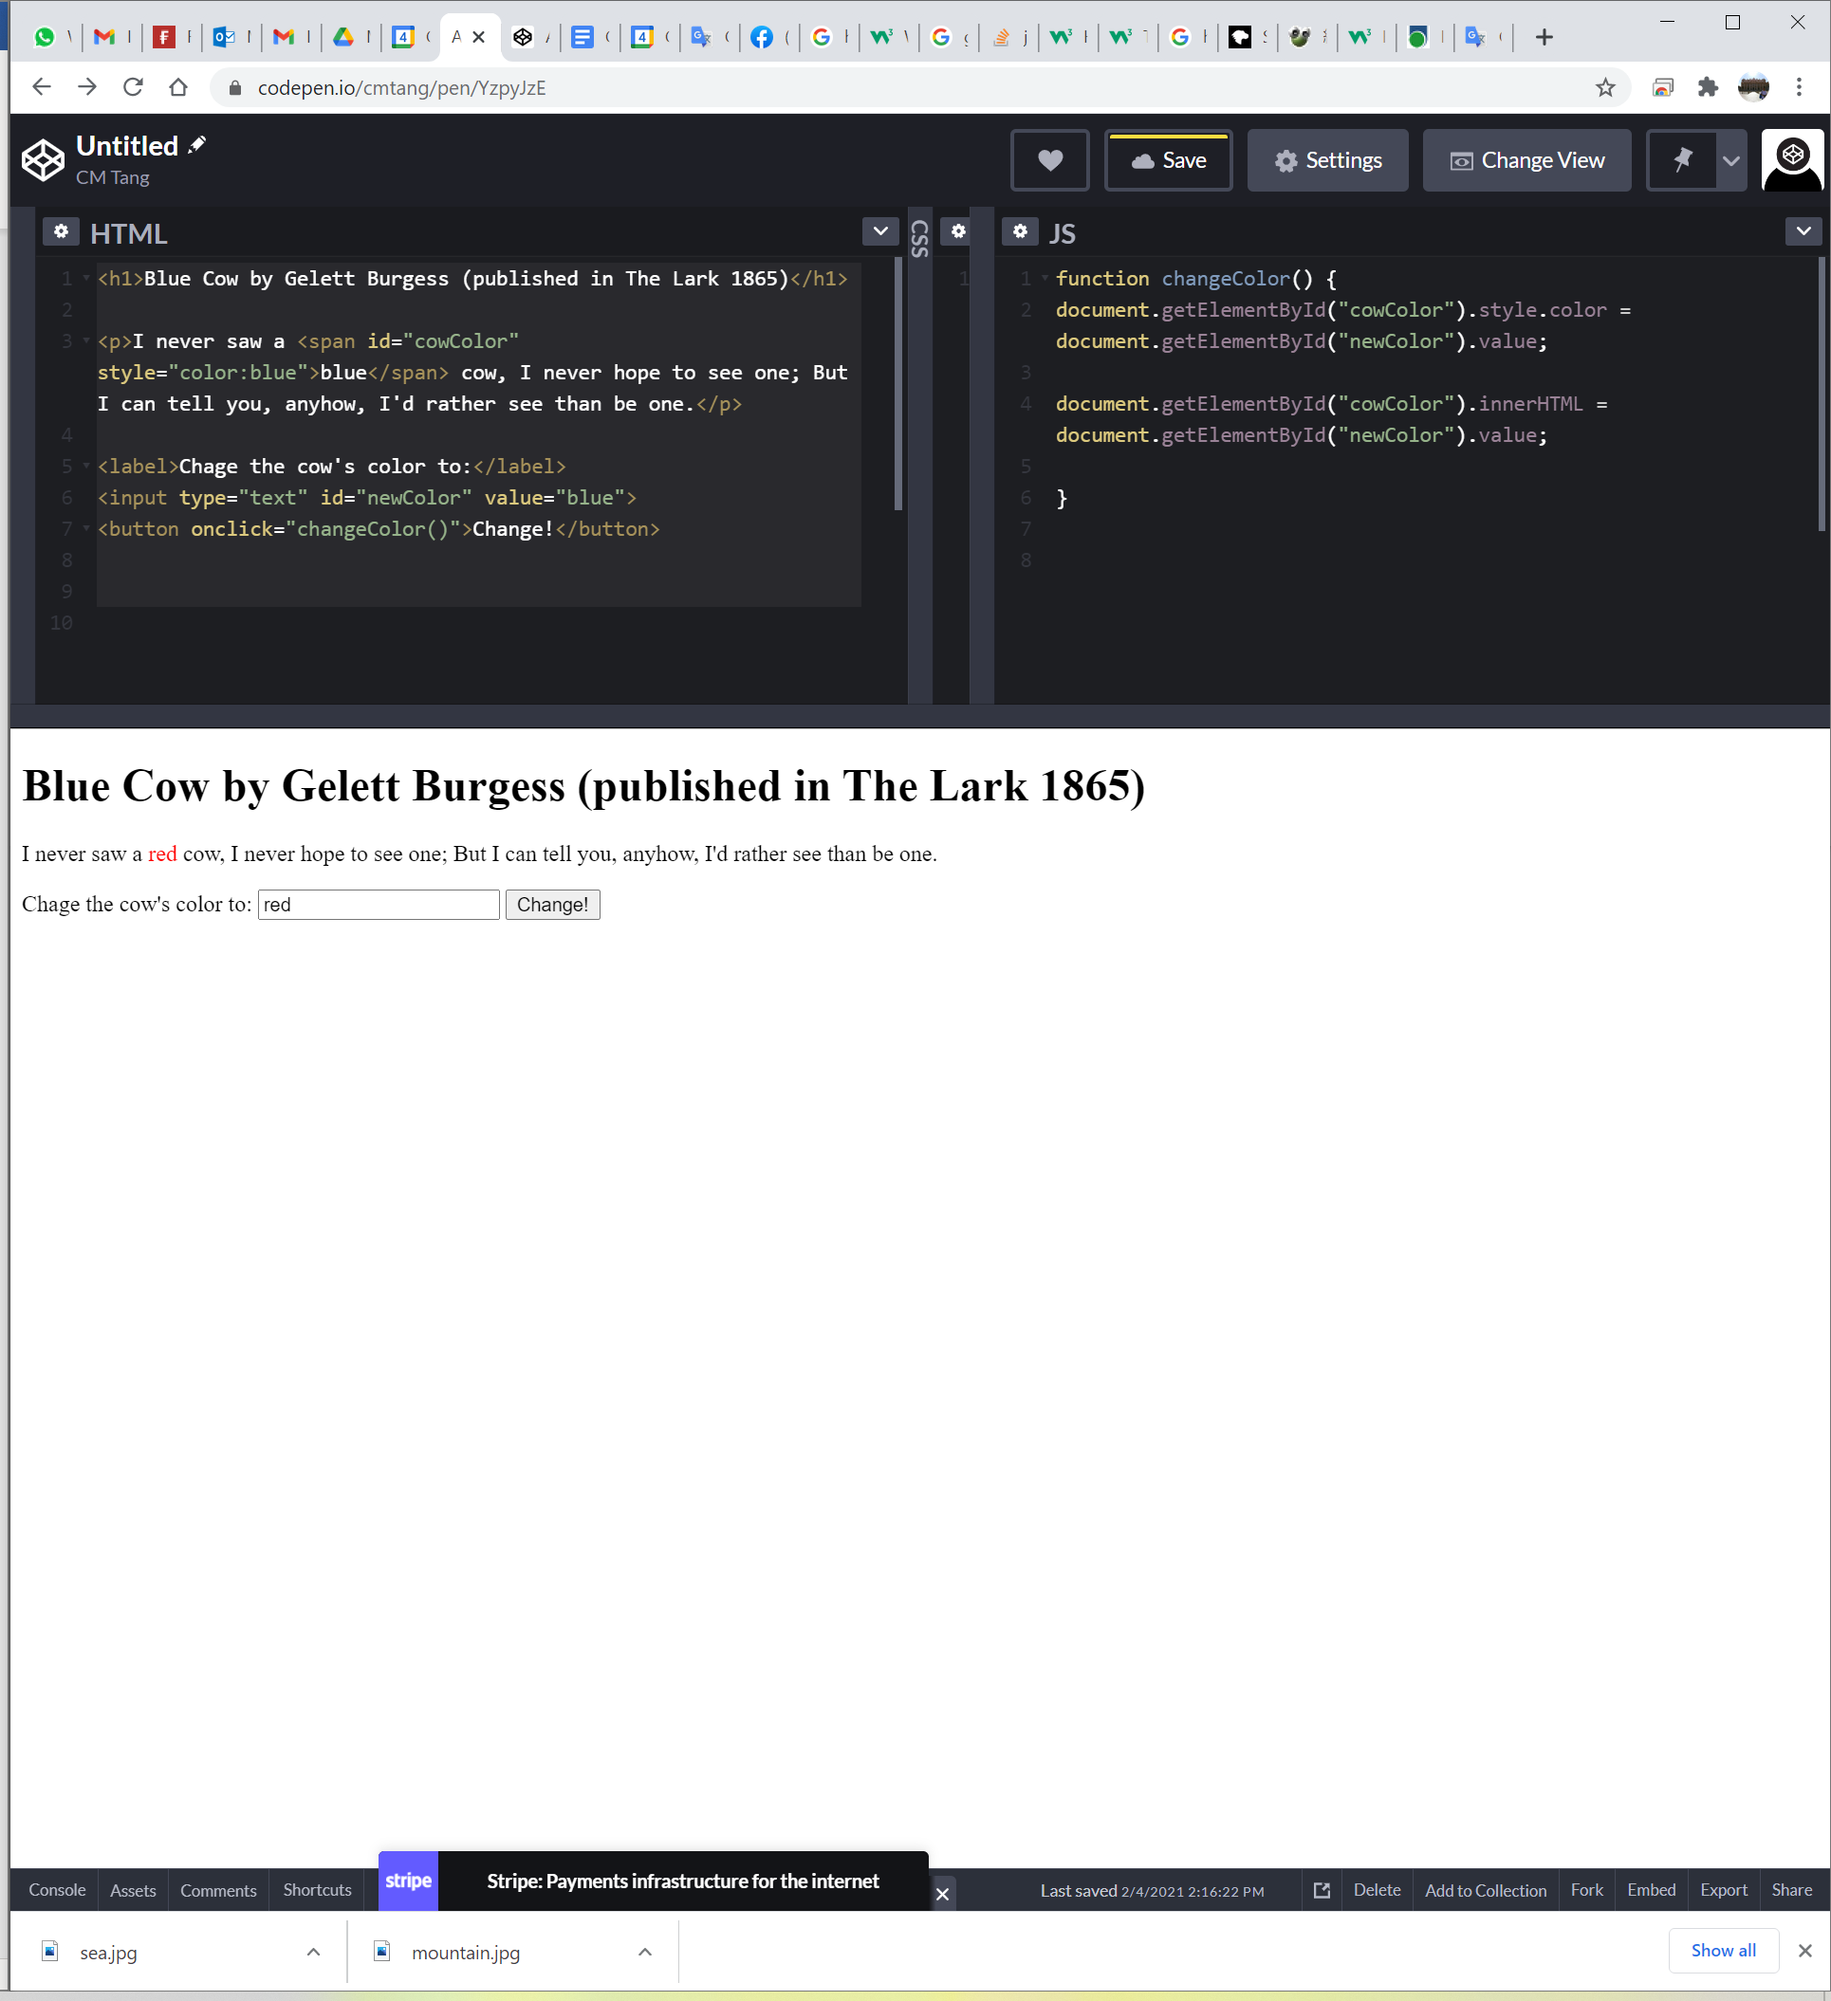

|  |
| --- |
| **Given HTML code (no update is needed)** |
| <h1>Blue Cow by Gelett Burgess (published in The Lark 1865)</h1>  <p>I never saw a <span id="cowColor" style="color:blue">blue</span> cow, I never hope to see one; But I can tell you, anyhow, I'd rather see than be one.</p>  <label>Chage the cow's color to:</label>  <input type="text" id="newColor" value="blue">  <button onclick="changeColor()">Change!</button> |

|  |
| --- |
| **Your Solution in JS** |
| function changeColor() {  document.getElementById(“cowColor”).style.color = document.getElementById(newColor”).value;  } |

**Submission**

You will get 0 to 3% of OCAS score upon completing the lab exercises.

1. Put your solution code inside the answer boxes and save the file.
2. Upload this file via the corresponding submission link on OLE.

**Note:**

1. The submission deadline is 23:59 of the forthcoming Thursday. The submission link will be closed after the deadline.
2. Your submission not necessary to be all correct but should show your efforts. We grade your work according to its quality.
3. Make sure you submitted a correct file. You can resubmit your work before the deadline.

1. DO NOT modify the layout and format of this document, and DO NOT save it as other file formats, i.e., PDF. Your work will be extracted using an automated document parsing tools for grading.

--- End ---